

EUROPEAN GOALBALL CLUB ASSOCATION

GOAL JUDGING TRAINING GUIDE

Welcome & thank you for volunteering as a Goal Judge. You will be playing a vital role in assisting the referees to determine when a goal has been scored and maintaining the flow of the game. We have created this guide to Goal Judging, along with a supporting video to help you prepare for the tournament.

*Please do take the time to read this document and watch the training video*

A. GOAL JUDGE OVERVIEW
Four (4) Goal Judges are required for each game, one (1) on each goal post.​ You will be assigned your games through the event organiser. If you have any questions during the tournament, please contact the event organiser through the agreed communication channel (e.g. event WhatsApp group).

B. POSITIONING
Stand at the post looking at play. Turn your body to look along the goal line (when the ball is approaching). Don’t touch or lean on the posts. Return to this position after each action.

C. GOLDEN RULES
DO:
- Make sure your mobile phone is switched off.
- Make eye contact with the referee if at any time you are unsure what to do and they will instruct you.
- Stand behind the goal at warm-up and:
  - pass the ball back to players if needed. Ensure you throw the ball gently, allowing it to bounce before reaching them so they can locate it.
  - protect the camera from incoming balls
- Consistently mop the court at time outs and half time and as requested by the referee (there is a lot of sweat!)
- Adjust the goalposts if they move during the game, but only during breaks in play or when instructed by the referee. Ensure the goalposts are positioned so that the goal line and sideline meet inside the post. (see diagram below)
- Maintain the flow of the game by anticipating where the ball will go, picking it up at the correct time, and putting the ball in play quickly and in the correct place.
- Anticipate where players may go, and always stay out of their way
  - players may choose to control a ball that has gone off court
  - players may purposefully go off court (i.e. to shoot or go to their team area)

DO NOT:
- Stop the ball with the side of your foot or hands. The balls can be thrown up to 40 miles an hour. Always use the bottom of your foot.
- Communicate with anyone on or off-court unless directly asked to by the referee.
- Put your feet on the court, including the lines, whilst the ball in play.
- Celebrate goals. You must always remain impartial.
- Be on your phone while goal judging.
- Touch players unless
  - (a) during a substitution – see section F
  - (b) during a penalty situation – see section G
- Re-orientate players at any time if they are lost.
- Pick up the ball during a timeout unless it has gone out of play, or you are instructed to do so by the referee. It is the team's responsibility to hold the ball.

D. HOW IS A GOAL SCORED & WHAT TO DO

A goal is scored when the ball completely crosses the goal line.
GOAL
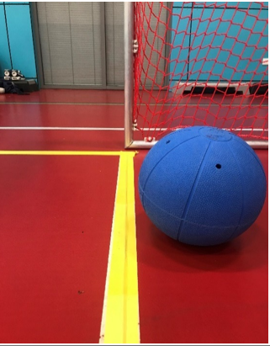
*NO* GOAL
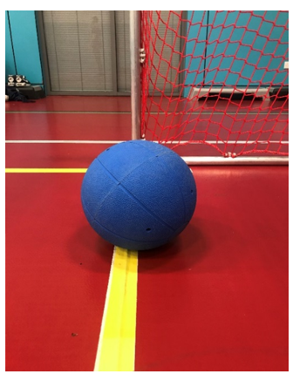

If a goal is scored in the goal you’re standing next to, raise your arm above your head to indicate a goal has been scored. The referee will then whistle twice and announce the goal. They may ask you to confirm that the ball completely crossed the line before announcing their decision.

Top Tip: Watch the ball as it moves towards the goal and turn to look along the goal line. Make sure the ball has completely crossed the goal line before moving to raise your arm above your head.
Be aware that the referee has the final say on whether a goal has been scored. If they are in a good position and can see clearly, their decision will take precedence, even if it differs from your view.
After a goal is scored, pick up the ball and put it back into play. However, players may choose to retrieve the ball themselves, which is allowed.

E. PUTTING THE BALL BACK INTO PLAY
Do not directly hand the ball to the players. Drop the ball back into play at the junction of the side line and 1.5m wing line in front of the goal post on the side the ball exited the court. This is always where the ball is dropped back in, and players will expect the ball to be there. The referee will then re-start the game.
Top Tip: Drop the ball in from approximately waist height as this will create a consistent bounce and most importantly create enough sound for the players to hear the ball being dropped in.
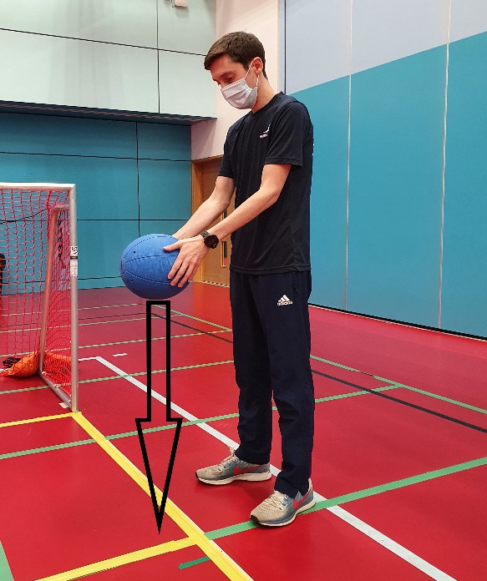

F. YOUR ROLE AT SUBSTITUTIONS (If you are Goal Judging on the Side of the Official’s Table)
Make sure that the outgoing player (number announced by the referee) comes off the court and goes to their team bench area. You may need to lead them safely to their bench area.
Then wait while the referee checks the eyeshades of the incoming player before you lead that player to the nearest goal post. Place their hand on the top of the post so the player can orientate.
Top Tip: At this elite level of competition, players need less support getting on and off court but remain alert and always be in position to offer support if required.

G. YOUR ROLE AT PENALTIES
If the team at the goal you are standing next to have to defend a penalty, the 2 players who are not defending will move off court. They can choose which side of the court they move off to. If they come your side, stand in line with the goal, with the player(s) behind you. Ensure these players are not touching the goal or nets. You may need to move players into position behind you. As soon as the referee has declared the outcome of the penalty move out of the way to allow these players to return to the court.
If a goal is scored, follow the instructions as above in ‘Section D: How a Goal is Scored & What to Do’.

H. MOPPING THE COURT & OTHER TASKS
There are other roles you may be asked to perform, such as drying the court, and handling any other tasks requested by the referee. At this elite level of play, the floor can become very wet through sweating. A wet floor is a safety risk as players can slip and injure themselves. During timeouts and halftime, please collect the mop from behind the goal and keep the court as dry as possible.
During active play, you may hear players call for a ‘wet floor.’ This is a player’s request to the referee to call an official timeout to allow the court to be dried. It is not an instruction for you to dry the court. Stopping play to dry the court is at the referee’s discretion. Do not attempt to dry the court during active play unless an official timeout is called by the referee, and you are specifically instructed to do so.

I. GOALBALL COURT DIAGRAM

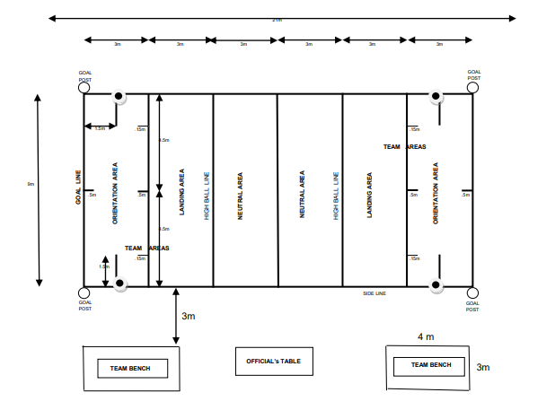
- Where the goal judge stands
- Where the goal judge puts the ball in play

